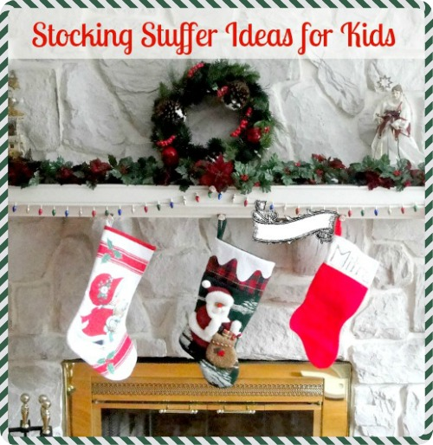

**Edibles**:

orange  
apple  
banana  
wrapped chocolate candies & miniatures  
Welch's Fruit Snacks  
sunflower seeds  or peanuts  
candy canes  
lifesavers  
mini-boxes iced animal cookies  
granola bars  
packet of hot cocoa w/mini marshmallows  
juice boxes  
mini boxes raisins  
bubblegum  
snack-size bags popcorn, pretzels, etc.  
dried-fruit snacks  
jerky and beef sticks

**Non-Edibles**:

school pencils & erasers  
8-pack crayons (for the littlest ones)  
8-pack colored pencils  
water paints w/brush  
mini coloring books  
travel-sized activity books, fun pads  
new toothbrush  
travel-size toothpaste  
travel-size hairbrush or comb  
barrettes & pony tail holders (girls)  
travel-size games  
deck of playing cards  
hand-held electronic games  
mini die-cast cars (boys)  
travel-size bubble bath  
soap crayons  
sunglasses  
change purse (girls)  
kid's sized wallets (boys)  
pair of socks  
gloves (smaller kids)  
winter hat (smaller kids)  
sticker sheets  
temporary tattoos  
jewelry and watches  
travel-size story books  
comic books for kids  
earbuds  
reusable beverage straws  
reusable beverage cups w/lids  
bookmarks  
keychains  
nightlights